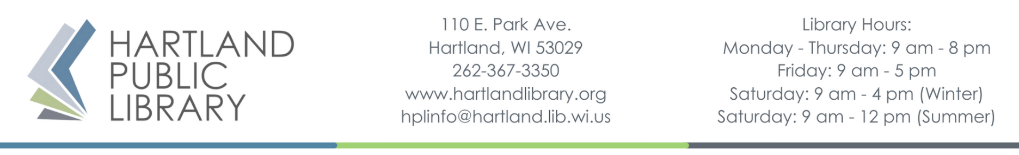

NERFTM Game Waiver – Underage Participant
NERF Game @ your Library!
Waiver and Release of Liability
Please read carefully
(Players 17 years and younger must have parent or legal guardian sign the waiver)
As the undersigned parent/guardian of the minor participant, ________________, and in consideration of the Hartland Public Library (including for all purposes of this document its employees, agents, and representatives) furnishing services and/or equipment to enable said individual to participate in NERF Game @ Your Library games, I agree to the following:
I fully understand and acknowledge that:(a) risks and dangers exist in his/her use of NERF equipment and his/her participation in NERF activities:(b)his/her participation in such activities and/or use of such equipment may result in injury or illness including but not limited to bodily injury, disease, strains, fractures, partial and/or total paralysis, eye injury, blindness, heatstroke, heart attack, or other ailments that could cause serious disability or death:(c) these risks and dangers maybe caused by the negligence of others, accidents, breaches of contract, the forces of nature or other causes; (d) these risks and dangers may arise from foreseeable or unforeseeable causes; and(e)by my child’s participation in these activities and/or use of equipment and facilities, I hereby assume all risks and dangers and all responsibility for all injuries, damages, losses and costs arising from or relating to my child's participation in such activities.
I, on behalf of myself, my child, my personal representatives and my heirs, hereby release, waive, discharge and hold harmless the Hartland Public Library from any and all claims, actions, or losses for any bodily injury, property damage, wrongful death, loss of services or other circumstances which may arise out of my child’s use of NERF equipment or participation in NERF activities, and I shall defend and indemnify the Hartland Public Library from any and all damages, losses, costs (including actual attorney fees) and claims arising from or relating to such use and activities.
I have discussed with my child the risks and responsibilities of participating in the NERF activities and represent that my child is sufficiently mature to understand the responsibility to abide by the rules, policies and instructions of the Hartland Public Library. I understand that these terms are contractual and not mere recitals. I have signed this document as my own free act.
I specifically understand that I am releasing, discharging, and waiving any claims or actions that I or my child may have presently or in the future for the negligent acts or other conduct of the Hartland Public Library relating to NERF equipment and activities.

We agree to fully comply with all the rules and directions. The Hartland Public Library reserves the right to remove my child from participation for failing to follow rules or directions.
I HAVE READ THE ABOVE WAIVER AND RELEASE, AND BY SIGNING THIS AGREEMENT IT IS MY INTENTION TO EXEMPT AND RELIEVE THE HARTLAND PUBLIC LIBRARY FROM LIABILITY FOR PERSONAL INJURY OF MYSELF (OR MY CHILD), PROPERTY DAMAGE, OR WRONGFUL DEATH CAUSED BY NEGLIGENCE OR ANYOTHER CAUSE.
______ By initialing this line, I grant to the Hartland Public Library, as well as news agencies, the right to take photographs of me or my child and my property in connection with the NERF Game @ Your Library event. I authorize the Hartland Public Library, its assigns and transferees to use and publish the same in print and/or electronically. I agree that the Hartland Public Library may use such photographs of me or my child with or without our names and for any lawful purpose, including such purposes as publicity, advertising and Web content.
Player’s Name: _______________________________________
Player’s Age: _______
Player’s DOB: ______/______/_______
Player’s Signature: _____________________________________________ Date: ____________________
Signature of Parent/Guardian (if under the age of 18 years):
_____________________________________________________ Date: _____________________
Phone: (_______) ______________
Email: ____________________________________________________
Address: _________________________________________________________________________________
City: ________________________________ State: _____________________ Zip Code: ______________
Emergency Contact (accessible during event): ___________________________________________
Phone: (_______) ______________

Forms will be kept on file for at least 30 days and may thereafter be shredded.

